Circular SME Scan in Hospitality 2023-1-HU01-KA220-VET-000153779
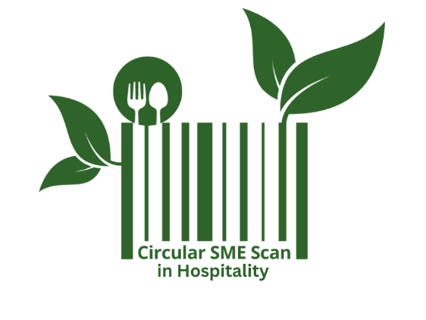
Erasmus+ project
You can find the following tools on the platform https://circularsmescan.eu/ in EN, ES, HR, HU, LT!

The hospitality industry has a significant environmental footprint, from food waste and energy consumption to water usage and carbon emissions. Embracing circular economy strategies not only helps businesses reduce their impact but also enhances their competitiveness, improves brand reputation, and aligns with increasing consumer demand for sustainable services. By leveraging the CSS-H learning materials, small and micro hospitality businesses can take meaningful steps toward a more responsible and resilient future.

- Self-scan tool
- Personas with circular journeys
- Learning materials
- Networks toolkit
- Methodology

Funded by the European Union. Views and opinions expressed are however those of the author(s) only and do not necessarily reflect those of the European Union or the Tempus Public Foundation. Neither the European Union nor the granting authority can be held responsible for them.

